Rook Census
The Committee decided that we should do a census of the rookeries in our area this year. The last full count was done in 2002 when we counted 2491 nests in 125 rookeries. Some partial counts have suggested that numbers have declined recently. However, we do know that there has been many changes in recent years, with many rookeries being deserted and other new ones starting. The best example of this is at Storrs Hall Arkholme which had the largest rookery in our area of 168 nests in 2002. Now it has been completely deserted and several new smaller sites have been colonised. Many rookeries are around villages, Burton-in-Kendal and Holme for example, both have rookeries right in the centre of the village. The map shows the rookeries counted in 2002, will be interesting to see the changes this year’s census brings
So we do need your help, we have counters surveying many of the old sites but local knowledge is essential to locate all sites especially the new ones. So please count your local rookery or any you notice elsewhere, between now and when the leaves make counting difficult in April.
All we need is a careful count of active nests and an accurate 6 fig grid reference and a local name. Grid references can be easily located by using gridreferencefinder.com/os. Please send details of you count to johnwilson711@btinternet.com Thanks so much for your help it is much appreciated.

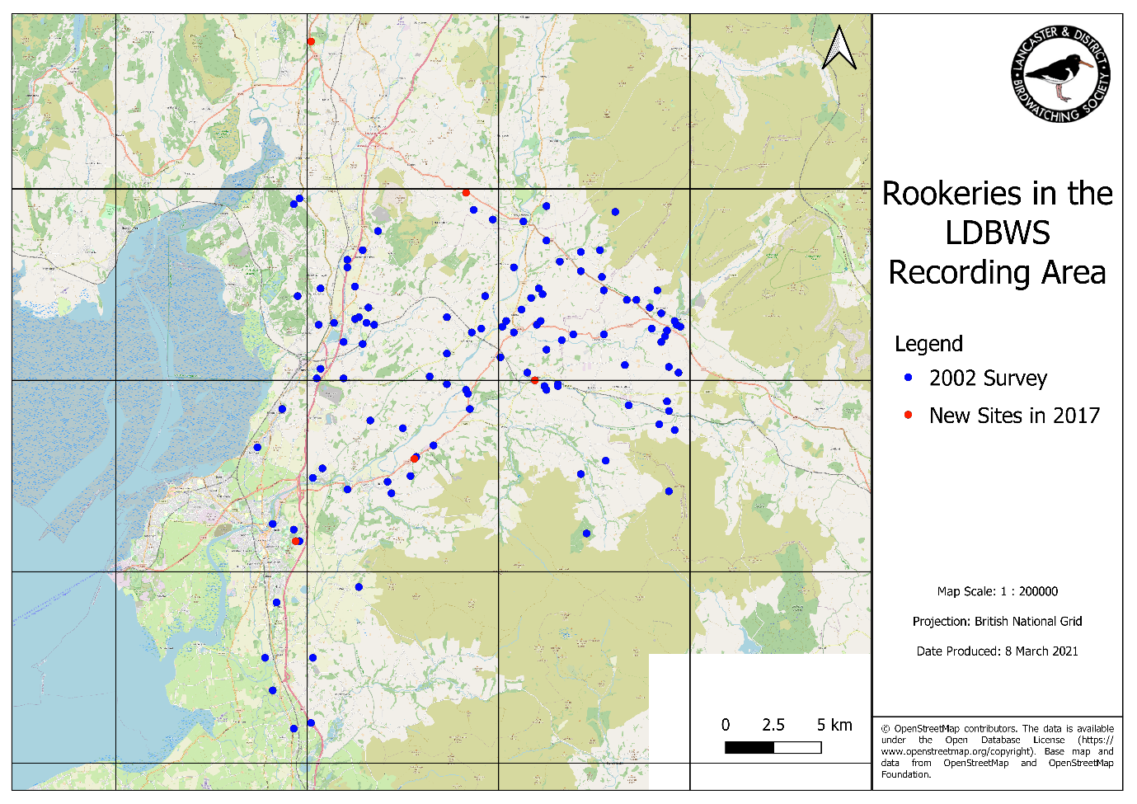
Thanks to Caroline and Nick for the map.

